Calculating Clutch: A Catch-Probability Model for Late-Game Red Zone Passes

Introduction

With two minutes left on the clock, the offense lines up in the red zone. The crowd roars, every movement magnified. A step, a glance, a throw. In this split second, the probability of a completion can decide the game.
While these moments appear unpredictable, data reveal consistent patterns shaped by player attributes, defensive schemes, and locations of the receiver relative to the defender and the ball. Our research aims to model these factors and estimate the likelihood of a pass being caught in the red zone during these crucial final minutes.
Advances in player tracking have changed that perception by turning passes made inside the red zone in the two-minute drill into measurable, modelable events. NFL Next Gen Stats now records the location, speed, and acceleration of every player and the football multiple times per second, generating hundreds of data points on each snap. These data open the door to quantifying how factors such as a receiver’s physical profile, separation from defenders, ball speed, and route movement actually shape completion probability, rather than leaving these relationships to intuition alone.​

Red zone performance already explains a substantial share of team success over a season, and most passing touchdowns originate from this compressed area of the field. Yet the red zone under two minutes is even more specialized: space tightens, defensive coverages compress, clock management magnifies the cost of failure, and coaches must decide whether to target contested windows or safer underneath throws. Despite the strategic importance of these situations, existing public metrics rarely isolate late-game red zone pass difficulty at the play level, leaving a gap between high-level efficiency stats and the granular dynamics of individual targets.​

Our team’s research addresses that gap by developing a predictive model for whether a pass will be caught in the red zone with two minutes or less remaining in the game. Using tracking-based features that capture receiver attributes, defender proximity, coverage type, route movement, ball placement, and throw characteristics, the model seeks to estimate catch probability for each target in these scenarios. The goal is to provide an interpretable framework that can support coaches’ decision-making, informing route design, read progression, and matchup selection in some of the most consequential moments in football.

I. Methodology
Our methodology for calculating the catch probability for passes targeted in the Red Zone during the final two minutes of play is grounded in a multi-stage, data-driven approach. This process integrates conventional exploratory analysis with advanced feature engineering and sophisticated deep learning and ensemble modeling techniques to convert granular tracking data into a reliable, interpretable predictive framework.

1. Data Acquisition and Exploratory Analysis
The foundational dataset contains the 2023 regular season of NFL play-by-play statistics and Next Gen Stats player tracking data across 18 weeks. The data was sourced from three primary files: player-tracking data before the pass, player-tracking data after the pass, and a comprehensive supplementary data file providing play context.
A thorough Exploratory Data Analysis was executed to establish data integrity, understand inherent imbalances, and identify predictive patterns:
- Data Quality Assessment: 100% of tracking records were successfully merged with contextual data, verifying join keys and identifying expected missingness in fields such as penalty_yards.
- Target Imbalance: The overall pass completion rate of 69.02% confirmed a slight class imbalance toward the successful outcome (Completion), necessitating the use of specialized sampling techniques during model training.
- Situational Context: The EDA confirmed efficiency significantly erodes under high pressure, with the combined Two-Minute Drill Red Zone scenario exhibiting the lowest overall completion rate, 59.3%.

2. Advanced Feature Engineering
The critical second phase focused on transforming raw kinematic and contextual data into approximately 161 engineered features per player/frame. This dimensionality was necessary to capture the highly nuanced dynamics of player movement and game situation at the moment of the pass. The features were categorized across five primary domains:
- Kinematic and Physical Metrics: Standardized features such as smoothed speed, acceleration, and Jerk (rate of change of acceleration) were derived from tracking data. Advanced metrics included Velocity Vectors and proxies for Momentum and Kinetic Energy, grounding the analysis in physics.
- Relative Position and Coverage Metrics: Crucial spatial features included minimum distance to the nearest defender and local player count within a 5-yard radius, which directly quantify the spatial constraints of the Red Zone.
- Game Situation Intelligence: Binary and categorical flags were engineered to measure non-physical pressure, including ‘two_minute_drill’, ‘red_zone’, and Score Pressure Categories derived from pre-snap score differential.
- Route and Dropback Intelligence: Features such as historical success by route type, 3, 5, and 7 step dropbacks, and ‘route_complexity’ were created to encode the strategic intent of the offense.

3. Model Development
The predictive framework was constructed using two distinct models to address the primary objectives of trajectory prediction and outcome classification.

3.1. Player Trajectory Prediction (Modeling Routes)
The foundational task was to predict player trajectory to enable the calculation of race-to-ball metrics post-pass.
- Model: A 4-layer Transformer Encoder architecture was implemented using PyTorch. The model was augmented with Positional, Role, and Side embeddings to process the multi-dimensional sequence data.
- Training and Target: The model was trained using L2 loss (MSE) on targets encoded in a Relative Coordinate System. The output coordinates were predicted relative to the player's position at the last pre-throw frame, significantly stabilizing the learning task.
- Evaluation: The model was validated chronologically (Weeks 1-14 training, Weeks 15-18 validation) to ensure generalization to future, unseen games, achieving stable convergence.

3.2. Pass Completion Classification
The core predictive task was modeling the binary outcome: P(Completion).
- Data Aggregation: The frame-level features were aggregated to the play level by taking the value at the snap (the last pre-throw frame).
- Algorithm Selection: Four machine learning models (Logistic Regression, Random Forest, Gradient Boosting, and XGBoost) were trained on the aggregated feature set.
- Imbalance Handling: The training data was balanced using SMOTE to prevent bias toward the majority "Complete" class.
- Optimal Model: The XGBoost Classifier was selected as the final model due to its superior performance, achieving a test-set F1 Score of 0.8169 and an AUC-ROC of 0.7386. This model provided highly calibrated probability estimates essential for the P(Catch) metric.
- Feature Interpretability: Analysis of the XGBoost model's feature importance revealed that ‘team_coverage_type’ and ‘receiver_separation’ were the dominant factors, confirming the physical and strategic drivers of pass difficulty.

4. Scenario-Specific Analysis (Two-Minute Drill & Red Zone)
To provide actionable coaching intelligence, dedicated descriptive analyses were performed on the intersection of the two most critical environments:
- Two-Minute Drill Analysis: Confirmed the sharp drop in offensive efficiency and identified the most and least effective routes and coverage schemes under time pressure.
- Red Zone Analysis: Isolated play tendencies in compressed space, confirming the dominance of Man Coverage (approx 50.2% frequency). Tracking data quantified the distance challenge, showing the median throw requires the targeted receiver to travel 11.42 yards to the ball's landing spot.
This comprehensive methodology ensures that the final P(Catch) metric is not just a high-performing statistical predictor but is rooted in the detailed spatiotemporal and contextual factors of high-leverage football.

II. Dashboard

Our research incorporates a comprehensive dashboard to summarize late-game passing performance and contextualize the modeling by visualizing how red zone efficiency relates to teams, concepts, and game situations. The top-level panel reports global key metrics for all passes in the two-minute drill, including total plays, overall completion rate, average EPA, average pass length, defender distance, and receiver speed, establishing the baseline environment in which individual red zone targets occur. This overview quantifies the high-pressure setting that often determines game outcomes rather than treating these plays as isolated or simply naming them “clutch.”
Route-level views highlight how efficiency varies over the season and by play design. A weekly performance chart plots completion rate and EPA by week, revealing that both EPA and completion rate tend to peak early in the season, around weeks 1-2, most likely attributed to the team’s health early on. EPA experiences a spike late in the season, around weeks 16-18. The conclusion here is that offenses raise their level of play to stay in the playoff race, leading to higher EPA but lower completion rate as they take more risks offensively. In parallel, a “Top Routes by Completion” panel compares completion rates across route types such as posts, corners, outs, and flats, indicating flat, angle, and screen concepts are the most reliable (all over 80% completion rate) in tight space when the clock is running down. Together, these views frame red zone decision-making as a function of both game-planning (which routes to call) and season-long adaptation.​

The dashboard also presents how space, coverage, and player movement impact catch outcomes. A defender proximity chart relates completion rate to yards of receiver separation from the defender at the catch point, illustrating how the likelihood of a successful pass changes from 92% at 10-15 yards of separation to as low as 46% at less than 2 yards of separation. A coverage panel shows completion rates against common defensive structures. The panel clarifies that zone coverage concepts (Cover 3, Prevent, Cover 4, Cover 2) often fail at disrupting late-game passes with offenses averaging over 70% completion rate on those defenses. Complementing the coverage type and defender proximity chart is a receiver speed module that links completion rate to speed buckets, indicating whether higher in-route velocity is associated with greater separation and success or introduces timing challenges that reduce catch probability. Interestingly, if a receiver is categorized as “very slow” (traveling 0-2 yards/sec), the average completion rate is over 80% on passes in the 2-minute drill. A “very fast” receiver (traveling 6-8 yards/sec) averages a 42% completion rate on passes in the 2-minute drill. Further showing how player movement, in this case, moving slowly or not at all, contributes to late-game passing efficiency.

Team- and formation-level panels connect these micro patterns to broader offensive and defensive identities. Rankings of the top ten offenses and defenses by EPA in the two-minute drill identify units from the 2023 season that consistently create or prevent value beyond raw completion percentage, highlighting schematically successful teams like the Baltimore Ravens, who averaged 0.51 EPA, as well as defenses that bend without breaking like the Tennessee Titans, who averaged -0.26 EPA allowed. A formations-by-EPA view further disaggregates offensive performance by personnel and alignment, showing which packages (such as spread or heavy looks) are most efficient when space is limited and time is scarce. The panel identified that formations typically used for running plays like Wildcat, Jumbo, and Pistol had a higher EPA than the formations that are used for passing plays like Shotgun and Empty. The results are most likely a result of running plays being a “safer” choice for guaranteed yards ,while passing plays can be riskier with higher rewards. This structure contextualizes late-game philosophies by bridging individual play features to strategic tendencies.

Finally, the dashboard incorporates explicit measures of time pressure and field position to link situational constraints with efficiency. A time-to-throw panel groups pass plays by release-time windows and reports associated completion rates, revealing extended pockets are slightly more conducive to completion rates (a 7% improvement from 0-30s to 30s<) in the two-minute drill. A comparative chart between red zone and non–red zone passes within the 2-minute drill plots both completion rate and EPA, demonstrating how the compressed field alters both success probability and value per play, with passes in the red zone averaging a lower completion rate than outside but having a much higher EPA. Collectively, these visualizations provide an interpretable map of the environment the model seeks to describe, clarifying how timing, space, coverage, and play design jointly influence whether a pass in the “clutch” is caught or falls incomplete.
III. Findings

Features of Importance
Late-game red zone football is fundamentally a problem of geometry and precision, which is exactly why closest_defender_dist (the distance in yards between the targeted receiver and the nearest defender at the catch point) and dist_to_ball_land (the distance in yards between the receiver and where the ball ultimately lands) emerge as the dominant drivers of efficiency in the model. In this part of the field, route depth is capped, safety help arrives faster, and throwing lanes collapse horizontally rather than vertically. As a result, most passes are thrown into windows that are both small and short-lived. The feature importance ranking is effectively quantifying that reality: as ‘closest_defender_dist’ decreases, the offense is no longer throwing to space but through a body, and in that regime even marginal deviation between the receiver’s location and ‘dist_to_ball_land’ causes completion probability to fall off steeply. ‘dist_to_ball_land’ is not just a measure of accuracy; in the red zone two minute context, it acts as a proxy for whether the quarterback and receiver successfully met at the exact landmark the concept is designed around.

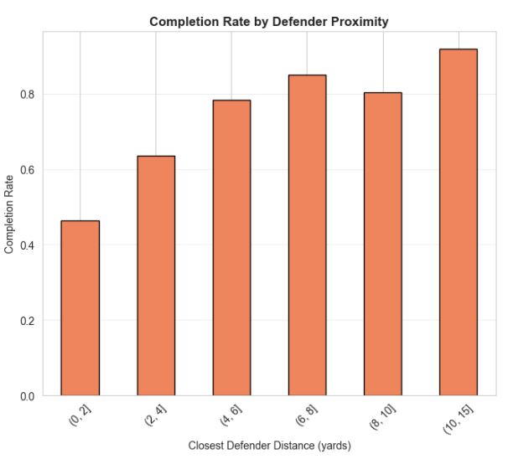
The route-level examples in the data reinforce this interpretation. High-performing pairings like Dak Prescott and CeeDee Lamb succeed because they repeatedly manufacture small but stable cushions of space and then hit those spaces on time. On a back shoulder fade or isolation route to Lamb, the gain in ‘closest_defender_dist’ might only be a step, but the ball is consistently placed where the defender cannot recover, outside the frame, at the back pylon, at the precise depth the route dictates as captured by ‘dist_to_ball_land’. If that throw drifts two yards inside or short, the defender’s effective separation shrinks to zero, and the play instantly shifts from a high percentage red zone target to a true coin flip or worse. The same pattern holds across quick outs, option routes, and shallow crossers in the dataset: when the receiver wins leverage, and the ball arrives exactly at the break point, the throw looks routine; when leverage is lost, or the ball is off spot, the identical concept looks like a low percentage gamble. In other words, the model’s emphasis on ‘closest_defender_dist’ and ‘dist_to_ball_land’ formalizes what high level offenses already coach implicitly: in the two minute red zone, the play call is only the starting point, and the game is actually decided in the extra half yard of space the receiver has from their defender and the extra half yard of accuracy from the quarterback.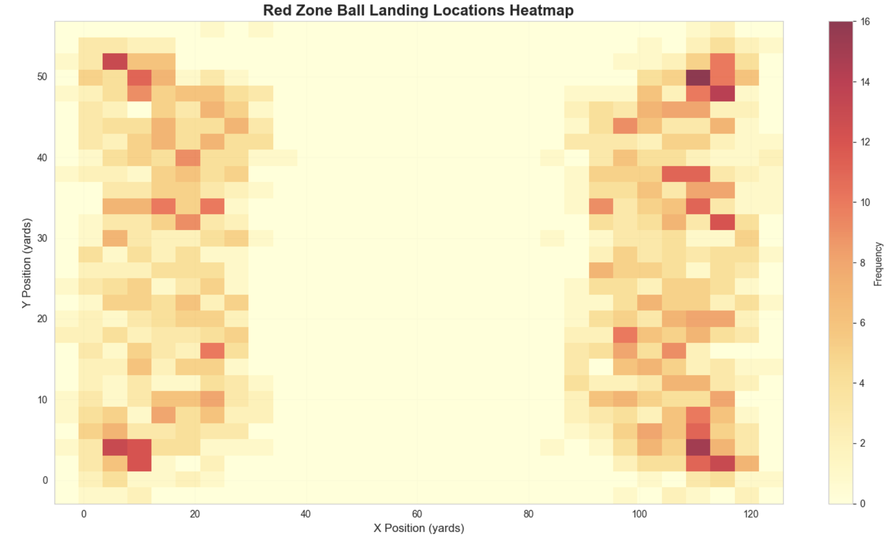
Evaluating “Must-Have” Plays
A must-have play represents the ultimate stress test for an offensive system. These are the critical, non-negotiable situations where the binary nature of the outcome (success or failure) carries disproportionate weight in determining the final game result. Our empirical evaluation of 491 critical fourth-down "must-have" passing scenarios reveals a significant shift in offensive efficiency and tactical reliability compared to standard game states. While the league-wide baseline completion rate remains robust at 68.7%, this figure suffers a marked degradation to 57.8% on fourth down, illustrating a "leverage penalty" where defensive aggression and the psychological weight of a potential turnover on downs compress the margin for error. Our analysis indicates that in these high-consequence moments, success is increasingly dependent on the specific geometric design of the pass concept rather than the overarching defensive shell. Contrary to conventional coaching intuition, the distinction between Man (59.1%) and Zone (56.6%) coverage yielded only marginal variance in completion rates, suggesting that at the elite level, the outcome is primarily governed by the precise execution of the route landmark and the manufacturing of marginal cushions of space.

The data categorizes offensive concepts into a clear hierarchy of reliability, providing a quantitative roadmap for situational play-calling.
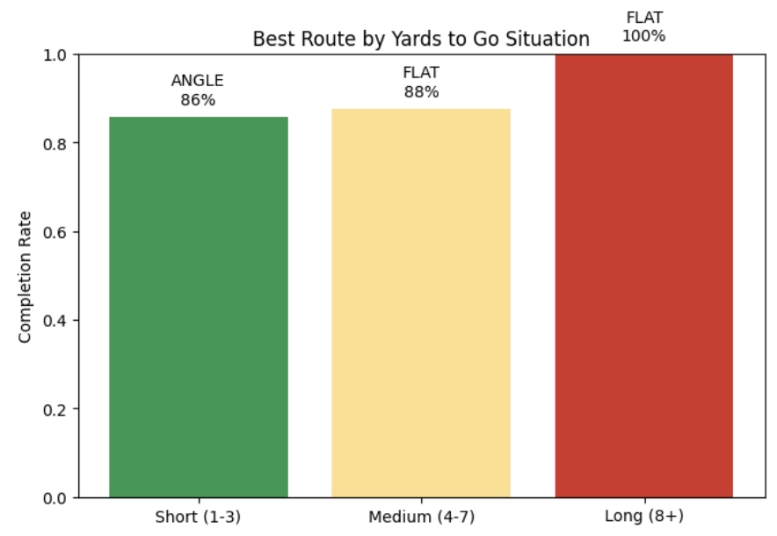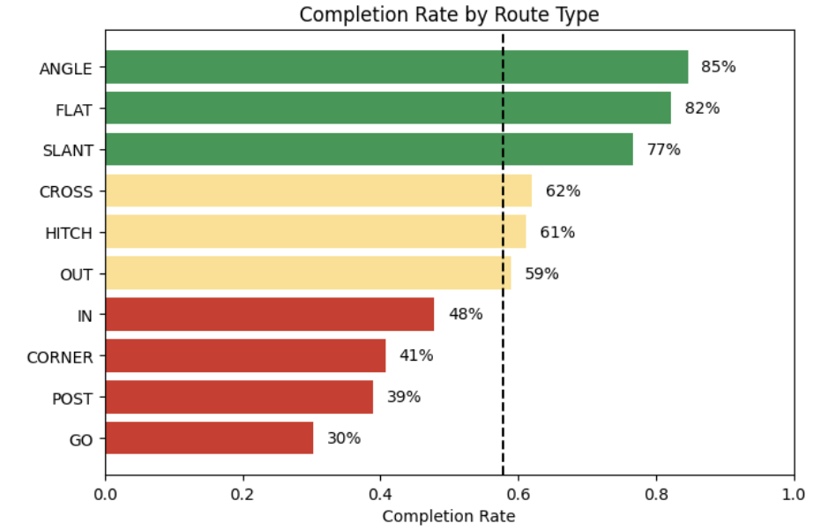
Horizontal-stretch concepts emerged as the most statistically stable options for moving the sticks; specifically, the angle (85%) and flat (82%) routes demonstrated elite efficiency by exploiting vacated "hook-curl" zones and forcing defenders to defend the full width of the field in a horizontal plane. Conversely, vertical and specialized perimeter concepts such as the go (30%), post (39%), and corner (41%) routes exhibited a catastrophic drop in efficiency, identifying them as statistically untenable options in must-have territory. This disparity highlights a critical tactical finding: in late-game or fourth-down scenarios, the marginal benefit of vertical explosive plays is statistically outweighed by the necessity of high-probability, low-depth targets.

Furthermore, the singleback formation yielded the highest conversion stability (75%), likely due to its ability to threaten the run and manipulate defensive density near the line of scrimmage, whereas spread-based configurations like empty and shotgun converged toward a significantly lower baseline of 57–58%. Ultimately, these findings formalize the "clutch" factor not as an intangible trait, but as the rigorous application of geometric concepts that maintain their integrity even as defensive windows collapse under maximal situational pressure.